Orators Report
on the 31st degree
Inspector Inquisitor
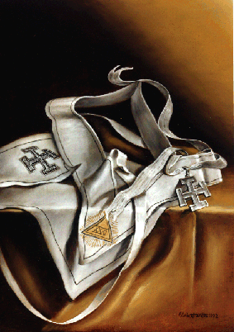
May 2, 2012
The apron is white lambskin lined and bordered in white. On the flap is a Teutonic cross.
Bremerton Valley of the Scottish Rite
The Legend: The Consistory comprises the 31st and 32nd Degrees. The word consistory derives from the Latin consistorium, which means both "tribunal" and "imperial council." As with other degrees of Freemasonry, the consistorial degrees present some of their lessons by borrowing the legends and symbols of other cultures and times.
The myths of the ancient Egyptians are compiled in scrolls, known as The Book of the Dead. The scrolls describe the rituals undertaken by the departed to gain eternal life among the gods. These scrolls suggest that the Egyptians always associated the Last Judgment with the weighing of the heart on a pair of scales in the Judgment Hall of Osiris.
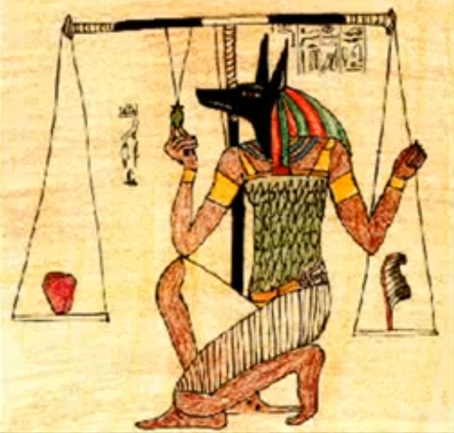
The Setting: The Hall of Justice in the Court of the Dead of Egyptian mythology. In the center of the hall is a large scale-beam, or balance. On one scale rests a vase shaped like a heart; on the other scale is a feather representing the goddess of truth. If the heart outweighs the feather, the deceased will suffer the final complete death. Gods sit in the Hall of Justice as Officers of the Tribunal.
The Ritual: The Candidate represents the soul of Cheres. Horus, the Master of Ceremonies, presents Cheres to Osiris and the Tribunal for judgment. Cheres is told that he will be judged according to the deeds he performed while alive.
Cheres is presented with a series of questions. Each set being more probing than the previous set. It is evident from the questions of the Tribunal that they are not satisfied with one who has merely obeyed the laws and outwardly represented himself as good man. Cheres finally passes the inquisition learning that a truly good man must actively correct his errors, repent his sins, and assess and improve himself, not for acknowledgment or reward, but for its own good. He must be active, not passive, in his efforts to improve himself and to improve the world around him.
Thus the scale of truth is found to weigh more than the heart and Cheres soul is allowed into the realm of everlasting light.
The Lecture: The 31st Degree reveals the dynamic relationship that has existed for centuries between human law as a means of achieving justice and divine justice as an ideal. It asks all of us to judge ourselves in the light of this knowledge and the lessons of the proceeding degrees.
This degree conveys the thoughts of self-examination. Every man, and more especially every Mason, should meditate prayerfully and soberly on his thoughts and acts of the day. The wrongs of today must not be repeated on the morrow, for each day should add some light and truth for our guidance for the next, and then as time goes by, our characters should be so far above reproach, so filled with the love of our fellowman, that the world would instinctively say: "There is a good man, for he is a Mason." To correct the faults of others, to admonish with love and forbearance, is a duty we owe each other, but never to judge, for that is a divine prerogative alone.
Ever remember that, being human, you must of necessity often err; that those who hold different opinions entertain them as honestly as you do your own; and that you have no right to deny or doubt their sincerity. Especially, never harshly denounce an opinion that more experience and a more thorough investigation may someday compel you to adopt; and therefore always treat your opponents as if their opinions were at some time to become your own.
No man is truly wise who is not kind and courteous, charitable in his construction of men's motives, lenient and distrustful of his own ability to resist the allurements of temptation, and afraid of the mighty influences of prejudice and passion.
Remember that what the letter of the law does not prohibit, is often forbidden by generosity and decency.

In this degree, the Mason learns prayerful self-examination. The mistakes today should not be committed tomorrow. Simply, the daily look at one's self to learn to live with the future. He presents himself for examination. By acting honestly in first giving judgment on himself within the principles of justice and equity, it should not be doubted when he shall do the same to his brothers.

DUTIES
- Judge yourself in the same light as you judge others - consider both actions and motives.

LESSONS
- The good man is able to portray himself and his actions positively and not simply assert the absence of wrong in his life.
- Justice and mercy are two opposites which unite in the great harmony of equity.
- To aim at the best but be content with the best possible is true wisdom.

FOR REFLECTION
- Is a man a thief who steals a loaf of bread for his children?

IMPORTANT SYMBOLS
- Balance, heart, columns, sages, Tetractys.
The collar is white and at the point upon the breast is a gold triangle emitting rays with the letters 'xxxi' in the center.
The jewel of the degree is a Teutonic Cross of silver worn with a white watered ribbon around the neck.
There was an apron that was to be worn when an Inspector Inquisitor visited an inferior body. That custom has been dispensed with, but it is displayed here for historical purposes. It is of pure white lambskin with a Teutonic Cross embroidered in black and silver upon the flap.

Adapted from Rex R. Hutchen’s book A Bridge to Light

